Cycle Bus, Ireland

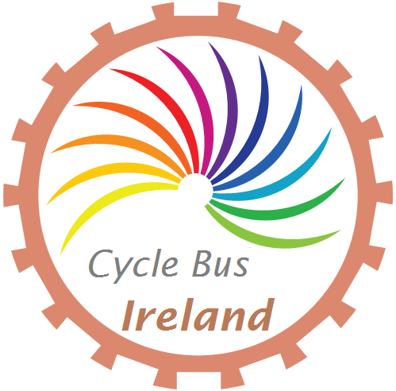

Planning Document
Version 1.0, February 2019

Table of contents

Table of contents 1
1 Purpose of document 3
2 Introduction 4
2.1 Concept 4
2.2 Description of area 4
2.3 Unmet need for the bus 4
2.4 Suitability of route(s) 5
3 Putting together our plan 6
3.1 Final route selection 6
3.2 Support, engaging with stakeholders 7
3.2.1 School management and staff 7
3.2.2 Parents 7
3.2.3 Students 7
3.2.4 Volunteer marshals and organisers 8
3.2.5 Other organisations 8
3.3 Sign-up of students 8
3.4 Risk assessment 9
3.5 Marshal organisation 9
3.5.1 Minimum daily number required (related to mitigating risks listed above) 9
3.5.2 Marshal pool 10
3.5.3 Initial plan for marshals 10
3.6 Equipment required 13
3.7 Communication 15
3.7.1 Parents, schools and teachers 15
3.7.2 Marshaling group 15
3.7.3 Use of social media 15
3.8 Vetting 16
4 Report on the service to date 17
4.1 Basic descriptive statistics of the service run 17
4.2 Summary of response from public 19
4.3 Summary and response to any safety incidents 19
4.4 Engagement from local authorities 19
5 Learning from our experience 20
5.1 Route of service 20
5.2 Schedule of service 20
5.3 Cancellation of service 21
5.4 Incidents 21
5.5 Equipment 23
6 General recommendations 24
6.2 Route selection 24
6.3 How to perform a risk assessment 25
6.4 How to engage stakeholders 26
6.5 Marshal organisation 27
7 Future plans 30
7.1 Return Journeys 30
7.2 Expansion in Galway 30
7.3 Family school cycle 31
7.4 Campaign for improved cycling infrastructure 32
8 Frequently asked questions 33
9 Acknowledgements 35
10 Appendices 36
A. Participant Code of Conduct 36
B. Marshaling Code of Conduct 37
C. Participation form 38
D. Letter to parents 39
E. Incident sheets 40
F. Accident report form 41
G. Marshal rota 42
H. Bike maintenance form for parents 43
I. The nature of the Cycle Bus route and the current marshalling process. 44

1 Purpose of document
In September 2018, a group of parents, teachers and volunteers in Galway began the first regular Cycle Bus for primary school children in Ireland, operating every day during school term. It was created to allow students to cycle to school safely, and encourage other children and parents to look at more active ways to travel to school.

We have written this document to share with other communities around Ireland our learning to date. It is in no way a complete document, and represents our reflections of only 4 months of service. We are treating our initiative as a working concept and are constantly striving to improve the service through constant feedback and reflection. This document should be treated as such.

Communities and schools around Ireland have their own particular needs and concerns. Every route to school has a diverse set of challenges that need to be overcome in providing safe access to students, and we hope that some of the lessons that we’ve learnt can help frame your own approach to setting up a Cycle Bus in your area.

While we would love nothing more than to help create a network of Cycle Bus communities, our narrative will continue to be that this should not be a necessity. Children of all ages should be able to cycle safely to school without adult escort. However, until authorities invest in a segregated and integrated network of cycle lanes linking our communities to schools and businesses, we must find an alternative approach, and the Cycle Bus initiative is just one strategy that could be pursued.

2 Introduction

2.1 Concept
A school cycle bus is a group of school children who cycle to school supervised by adult marshals. Such an initiative can help to support parents on the school run and enables young people cycle, who would otherwise be driven to school by car. Hereafter, we refer to the version of such an initiative, as described in this document, as the Cycle Bus.

The initial aim of the Cycle Bus was to run a service to school between neighbourhoods in the western area of Knocknacarra and two schools in the eastern area (Gaelscoil Mhic Amhlaigh [GMA] and St. John the Apostle Knocknacarra Primary School [KNS])

2.2 Description of area
Knocknacarra, in the West of Galway City is a large (approximately 17,000), young (20% aged 12 and under), and diverse (83.4% Irish nationals) suburb of medium density, with housing predominantly consisting of semi-detached housing estates (figures from Census 2016).

There are 4 primary schools in the area with a total number of over 1,100 pupils enrolled as per 2016 Department of Education figures (figures for 2018 are higher still due to the expansion of these schools): GMA, KNS, Knocknacarra Educate Together School, and Galway Steiner School.

2.3 Unmet need for the bus
Galway City is typical of most Irish towns and cities in that travel in general, and travel to school is heavily car-dependent. The 2016 Irish Census reported that of the 6,431 children between 5-12 years in Galway City and suburbs travelling to school, only 139 (2.2%) travelled by bicycle, and 1,452 (22.6%) by walking. These are a small fraction of the 4,387 (68.2%) primary school children being driven to school by car. The pattern is broadly similar across the country, illustrating a national problem rather than one particular to Galway City.

Cycling infrastructure in Galway City is poor, with the few segregated, continuous cycle paths being no longer than a few hundred metres, and a culture where driving is seen as the only option for travel.

In Knocknacarra, permeability by walking or cycling (linkage to other estates and key amenities on low-traffic routes) in many housing estates is poor. In a particular case, the direct distance between a group of houses and their nearest school is approximately 1 km, but the walking distance is over 3 km due to walls between estates. As such, most routes to school will consist of sections on or along main roads, with potentially large volumes of motor traffic.

In terms of feasibility of cycling as a mode of transport and demand for safe cycling routes, a 2016 travel survey at GMA indicated that 13% of 362 children between 1st and 6th class (6-12 years old) travelled by bicycle (or scooter) to the school on a given day in June. While this is likely an overestimate of everyday numbers, in particular during winter, it indicates that there is a desire amongst children and parents for cycling to school in the right circumstances. The survey also indicated that 52% of children at the school were living within 2 km of the school and almost all were living within 5 km of the school.

A 2014 Green-Schools Travel survey in KNS asking students about their preferred method of travel to school, indicated that 46% of students would prefer to cycle, while 34% would prefer to walk. This makes a strong case for feasibility for most children to walk or cycle to school, given a safe route.

2.4 Suitability of route(s)
The number one priority for this service needed to be the safety of the children who use the bus. However, picking the safest route to the school may not maximise the users of the service, as such, a balance needs to be made. If there are large housing estates on the route, there needs to be safe access for the children that may join the Cycle Bus. A parent or adult may need to escort groups of children from their homes to meet the Cycle Bus at its nearest stop.

In creating the route and timetable, the candidate routes were cycled with a young school child numerous times to gauge the average journey time and traffic levels. These journeys were completed in a variety of weather conditions and different times to give a representative reflection of journey times and an idea of traffic density in the morning.

3 Putting together our plan

3.1 Final route selection
In putting together our final route, we took the following factors into account: Distance (approximately 2km), topography (relatively flat), catchment, following best available infrastructure (existing, yet substandard cycling lanes), timing (arrival time at schools), and levels of traffic along the route. See Appendix I for further details of the road network along the route.
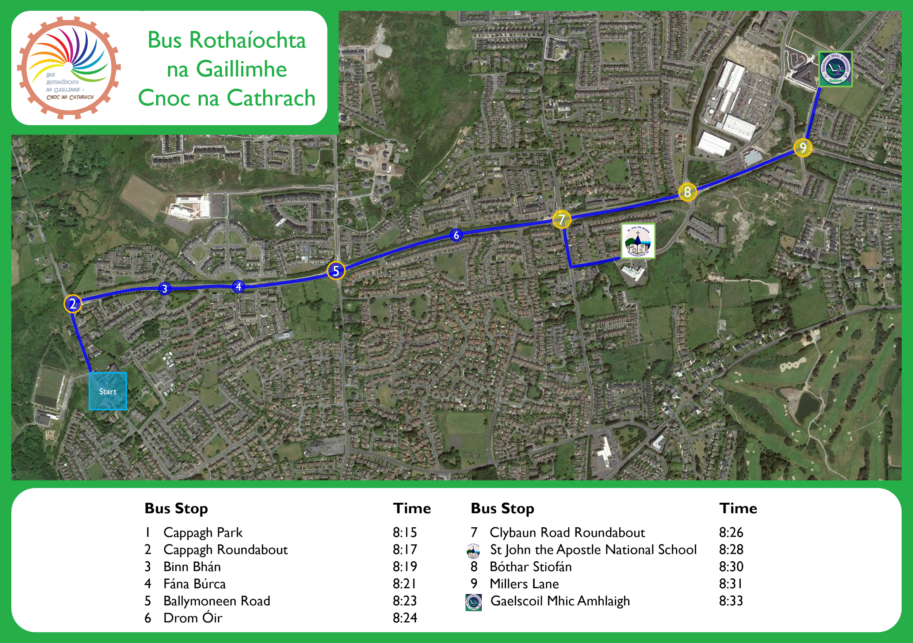
Figure 1. Final route selected. Key stops at housing estate entrances and the schedule are depicted.

3.2 Support, engaging with stakeholders
It was essential for us that the all stakeholders had some involvement in the initiative. We identified the key stakeholders and considered their role as follows in the following sections:

3.2.1 School management and staff
The full cooperation of the schools was sought. The Green-Schools coordinator of the school (most primary schools in the country will have a teacher in such a role) along with the principal, were the initial points of contact and the initiative was explained and permission was sought to circulate sign-up forms amongst the students.

In both schools, a teacher became the school liaison with the Cycle Bus. Their role is to work in tandem with the Cycle Bus planning team to ensure the needs and concerns of the school and children are met. This teacher also promoted the concept of the Cycle Bus directly to the school staff, students and parents.

3.2.2 Parents
Initial communication with parents began with informal meetings and word of mouth. It then became obvious that there was a demand by parents for a Cycle Bus service which would enable their children to cycle to school in a safe manner. Through our social media channels, more parents were contacted and their feedback was taken on board.

An email containing all the information pertaining to the Cycle Bus was circulated by both schools.

3.2.3 Students
Students were briefed on the procedures of the Cycle Bus when possible before the journey began. Children joining along the route for the first time, were guided and supported by the marshalls to the rear of the convoy.

Many children have not cycled on the road before joining the Cycle Bus, haven’t cycled in a long time or have low levels of fitness. We do our best to support these children through guidance, praise and encouragement. At times this involved showing them how to choose an appropriate gear for the incline, reminding them to leave a safe space between them and person in front of them or to keep both their hands on the handlebars.

To this point, students taking part in the Cycle Bus have always been compliant with instructions and respectful of marshals and other participants.

3.2.4 Volunteer marshals and organisers
One of the most essential requirements in delivering a frequent and reliable service, is having a pool of volunteer marshals to draw from. Having the minimum number of marshals per day to fill the core roles requires huge commitment from those volunteering their own time and convenience.

Initially many of the volunteers were parents and teachers, but as our service drew more attention, large numbers from the community got in touch to offer their time and support.

We contacted all the cycling organisations in the city including the Galway Cycling Campaign, Galway Bay Cycling Club, and the local cycle shops to help recruit volunteers. We also extensively used social media to spread the message.

All phone numbers and email addresses were taken, and all volunteers were added to our contact groups.

3.2.5 Other organisations
92% of Schools in Ireland are registered as part of the An Taisce Green-Schools programme, and many have completed the travel theme which aims to increase cycling and other forms of sustainable travel to and from School. We worked closely with the Green-Schools Galway coordinator in putting this project in place. A document created by An Taisce ‘Guide to organising a Walking Bus’ was extremely useful in helping to frame our own approach in the initial stages.

3.3 Sign-up of students
In one school, participation forms (Appendix C) were distributed by the school liaison throughout the school as they visited the classrooms explaining and promoting the Cycle Bus initiative. The liaison also collected forms from the children and acted as a point of contact for children and parents who wished to sign up later in the term. Forms were then filed by the school liaison in a secure filing cabinet.

In the second school, forms were collected from and returned to the office. Contact details of the participant’s parent/guardian were kept by the two lead marshals, for use in the event of an emergency or for sending notifications relating the to Cycle Bus

3.4 Risk assessment
An initial risk assessment of the route was carried out in Summer 2018, assessing the infrastructure, any steep climbs or descents, any physical hazards, the road or cycle lane surfaces and junctions, crossings, signals and school entrances. A full risk assessment was carried out in September 2018 when school traffic was deemed to be typical of most school days.

3.5 Marshal organisation

3.5.1 Minimum daily number required (related to mitigating risks listed above)
The absolute minimum number of marshals was set to be 4, to cover the 4 core marshalling roles described in 6.5. This number was generally felt to be too low if more than 10 children joined the Cycle Bus. The goal was to have 5 scheduled marshals everyday to provide greater cover for any last minute absences, adverse weather, incidents or increases in student numbers. In advance of mornings when greater numbers of children were anticipated, attempts would be made to have additional marshals present.

In reality, the numbers of marshals per morning varied from 4 to 8 (excluding the Family Cycle Day) and was typically 5. These should be interpreted alongside the number of children cycling per day in 4.1.

Parents cycling with children in 2nd class and under should not be counted as a marshal. These parents are required to accompany their child to ensure their safety and help develop their cycling skills. Parents of older children may decide to join the marshaling team, but only in an official capacity. As a general observation, the Galway experience has been that parents cycling with their children cannot be expected to leave their charges and switch to one of the mobile marshalling roles. The lead marshal should treat the marshals and the parents as two separate groups. Having parents with the Cycle Bus is still a great help and protection and takes one source of pressure off the marshals.

3.5.2 Marshal pool
Based on expected participant numbers and to spread the responsibility over the five days of the week, we recommend having a minimum of 15 volunteers from which to draw from.

A rota system was drawn up (Appendix E), and every weekend, volunteers fill out their available slots on the rota. If someone is unable to follow through on their commitment on a particular day, someone else available will be found for backup. This happens through our communications channels, where most volunteers are actively responsive, especially on weekday evenings or mornings to cover any last minute situations.

3.5.3 Initial plan for marshals
The role of the marshal is discussed below in 6.5, but it is important that the skills set and experience of the marshals matches the role. Typically the marshals are daily bicycle users who choose to combine their routine journeys, such as to work, with the Cycle Bus. In particular, experienced and confident cyclists should take the lead, rear, and junction marshal roles (described below). These key marshals should be confident commuter cyclists used to cycling in city traffic. They should have an understanding of the cycling skills and techniques taught under Units 3 and 4 of the UK National Standard. They will understand the main road positions, “secondary” vs. “primary”, and when and why they are used. They will understand how to negotiate roundabouts by bicycle and how to assess cycling infrastructure and decide if it is an aid to the journey. For the Cycle Bus marshals, a particularly important skill is the ability to look behind and make eye contact with other marshals or following drivers.

Those with less understanding of these skills are more suited to support roles until their confidence and understanding improve. There should be one marshal per day who has mechanical skills, and one marshal qualified in first aid should the need arise. These skills are noted on the rota to ensure availability every day.

All marshals are briefed on the logistics of the Cycle Bus and the likely scenarios before they are entered onto the rota. New marshals take on an observer's role (support marshal) until existing and new marshalls feel they are capable of assuming an escorting role (usually a day or two in our experience). Volunteers are also required to read the guidelines from the 2008 edition of the Cycle Training UK Instructors manual, which details the approach marshals should take when guiding a large group of cyclists. The Volunteers are also asked to familiarise themselves with the Marshaling Code of Conduct (Appendix B). The qualifications and experience of all marshals are recorded and updated as appropriate.

List of supporting documents for the marshals
- Leaflet: Galway Cycling Campaign Cycling Skills for Adults
- Extract: Units 3 and 4 of the UK National Standard
- Extract: 2008 edition of the Cycle Training UK Instructors manual

3.6 Equipment required

3.6.1 Participants
All children are required to have the following:
- An appropriately sized bike in good working order
- Front and rear lights
- Wet gear
- Gloves

The issue of children wearing helmets has been heavily debated. We have decided that the parent is best placed to decide whether their child should wear a helmet on the cycle. As such, our policy is that helmets are advised, but not mandatory. We do not want to discourage children from cycling for whatever reason, and will not turn away a child who is making the effort to participate. To date however, all of the children have worn helmets on every journey.

The mechanical standard of the bikes for the students is an ongoing concern and parents need to take the responsibility to ensure their child's bike is in full working order. Where there is a simple fix (tyre pressure, saddle height), we will service the bike if necessary. However, some children will have bikes with more serious mechanical issue,s which cannot be quickly resolved by the marshals.

We have created a form (Appendix H) that the students can give to their parents, detailing the mechanical issue that has arisen, and any other concerns that we may have. We are planning on running courses within the school, where a local bike shop, or competent mechanic will come to the school once a term, and service the bikes as well as educating the children on simple bike maintenance.

Where a mechanical issue occurs during the commute, we have found it necessary to stop the Cycle Bus to keep the group together until the problem has been fixed. The students should move to to the footpath as they wait. A marshal should continue ahead to inform the other students that the bus is delayed.

All participants will also be given a free hi-vis vest. There are many organisations including the RSA and Green-schools who will provide hi-vis vests for no charge. We have negotiated with a Galway company, Safety Direct, to supply affordable branded vests in a variety of colours. The Galway Cycle Bus use two different colour vests on our bus, one for each school.

3.6.2 Marshals
The marshaling group have the following mandatory equipment:
- Pump
- Spare tubes
- Simple mechanical set
- First aid kit
- Front and rear lights on each marshal’s bike

Other equipment:
- Cameras
We recommend the purchase (in time) of cameras for the front and rear marshals at a minimum. It is critical that all incidents are recorded, however slight.
- Trailer or cargo bike
We have discussed the use of a trailer for carrying school bags. Our survey of parents has indicated that some are reluctant to let their children cycle due to the weight of their school bag. The rear marshal using a trailer or cargo bike could mitigate this issue. However, there is a logistical complexity of getting the children to put the bags on the trailer without disrupting the operation of the Cycle Bus. We will continue to experiment and investigate this issue.

To fund the purchase of the hi-vis vests, and other necessary equipment, we received generous donations from two nationwide companies. These companies have indicated that they are willing to support the expansion of other Cycle Buses in other communities around Ireland. Please get in touch with us for further details.

3.7 Communication

3.7.1 Parents, schools and teachers
Our communication with the parents is two-fold. Our school liaison and principal have emailed all parents information relating to the launch of the Cycle Bus and Cycle Bus Family Days.

On the rare occasions when the Cycle Bus needs to be cancelled (e.g. poor weather conditions, only on orange and red weather warning) the school liaison will inform the students in person, or the principal will send out an email to parents. In addition, we also send out a text message to the registered parents to ensure everyone is well informed. The Cycle Bus phone number is also a contact point for the parents of the registered students, in case they have an urgent or last minute query or concern.

3.7.2 Marshaling group
To keep all the volunteers and marshals in contact and up to date with the latest communication, the Whatsapp group-chat application is used as the main communication tool on a daily basis. All volunteers who join the initiative are asked to provide their email address and phone number, and are linked into the groupchat.

For more formal communication within the group, we use Google Groups to email documents or details around the subgroups within the team. In addition, Google Drive is used to store all documents related to the Cycle Bus (list of participants, marshals, forms, etc.)

On a daily basis, the marshals in attendance have a very brief meeting upon arrival at the last school, to reflect on the days journey (discuss the marshals general feeling of the journey, or any issues that occurred). Once a month, we conduct a more formal meeting to discuss issues that have arisen and to create strategies for the future.

3.7.3 Use of social media
For external communications and to keep the public updated with the statistics and projects of the Cycle Bus, we use two social media platforms, Twitter and Facebook. Our Twitter handle is @cycle_bus, and our Facebook profile is @galwaycyclebus.
We also have created a website using www.weebly.com. This site allows us to store all our public information and documents in an easily accessible place, where interested parties can download all the material relevant to our service. This platform is free to use, and very user friendly. Our website is www.galwaycyclebus.weebly.com.

3.8 Vetting
“The National Vetting Bureau (Children and Vulnerable Persons) Acts 2012 to 2016 provide a statutory basis for the vetting of persons carrying out relevant work with children or vulnerable persons. The Act also creates offences and penalties for persons who fail to comply with its provisions.
The Act stipulates that a relevant organisation shall not permit any person to undertake relevant work or activities on behalf of the organisation, unless the organisation receives a vetting disclosure from the National Vetting Bureau in respect of that person”
Galway Cyclebus is not a registered charity or organisation. It is an organised group of parents, teachers and volunteers who cycle children to school on a daily basis. As a result, there is no legal obligation on us to ensure that our marshals are vetted. In fact, we cannot vet an individual through our group, unless we formalise our structure into a registered group or charity.

However, as it stands, 70% of our marshals have been vetted through their own employer. We ensure that at least one of the externally vetted volunteers is on the bus everyday. We are exploring with the Galway Volunteer Centre as to whether we can vet additional marshals through their organisation, to ensure we achieve 100% compliance.

4 Report on the service to date

4.1 Basic descriptive statistics of the service run
Some summary statistics of service until end of year 2018 (12 weeks) are as follows:

- A total of 762 individual student trips were made.
- This accumulated to 1,219 km travelled, assuming an average distance travelled of 1.6 km per trip.
- Typically 14 students per day travelled on the service (median number).
- On 90% of days (50 days), more than 5 students travelled.
- On 20% of days (11 days), 20 or more students travelled.
- On 10% of days (6 days), rain during the trip was deemed to require wet gear.
- Only 3 days of service were cancelled due to stormy conditions.
- No days of service were cancelled due to an insufficient number of marshals to run the service (a minimum of 4).

4.2 Summary of response from public
Our main point of contact with members of the public are generally in person, or through social media channels. The response from the public has been overwhelmingly positive, but we do try to seek as much constructive feedback as possible. Speaking to parents outside of the schools, has been a valuable learning experience.

Contact through social media has also been positive, and has led to quite significant interest from the media. We have conducted interviews on local and national radio stations, and have been featured in two newspaper articles, local and national, and more recently have featured on RTÉ news during the launch of our Family Cycle Day on the 25th January.

4.3 Summary and response to any safety incidents
There have been a handful of incidents we have experienced, which have caused us to reflect on our actions, and the actions of others. While the vast majority of motorists have been extremely courteous and helpful (traversing roundabouts with a large group of cyclists requires the cooperation of all motorists), we have experienced aggressive driving, and close passes. Where we deemed necessary, we have contacted the authorities to report these cases.

We have also reported to the authorities, situations where we felt compromised the safety of all users. These include heavy construction vehicles on the road at inappropriate times, cars and trucks park on cycle lanes and footpaths, and other obstructions and safety concerns such as broken glass and debris.

4.4 Engagement from local authorities
We engaged with the local authorities in Galway City Council at the very beginning of this project, and detailed how every step of this initiative would be planned and implemented. The City Council however, declined to support the project.

We have however, continually sought their advice and feedback, and are currently liaising with them to identify and solve permeability issues that restrict active travel from the community to the local schools.

5 Learning from our experience

5.1 Route of service
There was initially an obvious route of approach to KNS from the north-west main entrance. This would ensure that both groups would travel together for longer and avail of the cycle lanes on the final 150m of the only road with vehicular access to the school. However, it soon became apparent that car parking (in the cycle lanes themselves) and the heavy car traffic on this approach road would increase the risk to the children cycling and make escorting them in a single, protected group more challenging. The approach to KNS was modified to use a rear pedestrian and cyclist entrance to the school through the Doire Gheal housing estate. This approach is generally free from cars driven by parents dropping children at the school.

5.2 Schedule of service
The creation of the timetable took three factors into account. The distance of the route, the appropriate speed of the Cycle Bus, and the starting time of school.

The initially scheduled start of the Cycle Bus was at 8.10, which would mean students would arrive at 8:23 at KNS and 8:28 at GMA. School days begin at different times at these schools; 8:40 and 8.50 respectively. Thus there was a balance to achieve in getting children to school in sufficient time at KNS and avoiding children waiting outside GMA before the school building opens at 8.40. Some parents and children were also reporting that they would occasionally arrive on the route late, after the Cycle Bus had passed.

As the mornings grew darker in early December, and based on the above considerations and comments from the marshalling group, we decided to modify the starting time to 8:20. This would still ensure that both groups would arrive in advance of the school day beginning, that visibility would be better, and hopefully enable more children and parents to travel on the service. We did however notice that traffic levels were heavier at this time, which presented an increased challenge at roundabouts and required more filtering around stopped traffic.

As of mid-January, we have reverted to a departure time of 8.15, and find this to meet both the needs of the children using the service and ensures their adequate safety.

5.3 Cancellation of service
We have found it necessary to cancel our service on five occasions, all weather related. During orange or red weather alerts, we contact all parents and students through all our communication channels to inform them that the Cycle Bus will not be running on a particular day. To ensure that no child is left behind due to a communication error, we have always ensured that at least one marshal has scouted the route when appropriate.

Since we have started, there have been three orange weather alerts relating to high winds and we have cancelled on these days. On two consecutive days (January 2019) we had to cancel the service due to yellow weather warning relating to freezing conditions. Although roads were gritted, cycle lanes were not. This led to hazardous conditions for cyclists in heavy traffic. The footpaths were not gritted either, so crossing busy junctions by foot, was not an option.

Other weather conditions such as heavy rain or snow, may require the service to be cancelled.

5.4 Incidents
Sharing space with cars, vans, buses and HGV’s during the busy school rush will inevitably lead to conflicts. On all occasions, we have felt that as a marshaling team, we never took unnecessary risks with the students, and that all minor incidents that we have experienced were as a result of motorists acting in an irresponsible manner.

5.4.1 Cycling two-abreast
The positioning of the Cycle Bus on the road is discussed above. In particular, the necessity of cycling two abreast in the secondary position, and moving to the primary positions for every junction. Some parents were concerned that in cycling two abreast we might antagonise other road users, or felt vulnerable to passing traffic. In our experience, moving to single file to allow traffic to pass that has built up behind the bus, only resulted in motorists and other larger vehicles aggressively passing us without regard for the minimum safe passing distance (1 Metre where the speed limit is ≤50 km/hr and 1.5 metres >50 km/hr). We therefore strongly discourage it.

In reality, with heavy congestion building up on the road network, any delay that a motorist experiences by being behind the bus is negated by their arrival at the next inevitable traffic jam, with the Cycle Bus proceeding unimpeded on the inside cycle lane.

5.4.2 Dealing with conflict
While most other road users are cooperative, some may choose not to be and may act or drive in a manner that feels threatening towards members of the group. In this situation, we found it best, for the marshals to remain calm and avoid letting themselves feel provoked. Marshals should not respond to aggression in a like manner, but instead refuse to engage and try to deescalate the situation, reporting any serious dangerous behavior to the authority if felt necessary (videos are a good material provide as a proof). We produced a number of “first principles” for our marshals during our initial phase, which included simple guidance on how avoid confrontation.

The children may not be aware that another road user’s actions are causing concern to the marshals, however if they see adults acting aggressively, this in itself can be unsettling for a child.

Marshals must deal with conflict in a non aggressive way, as other parents in traffic will see aggressive behaviour and it can lead to poor PR for the Cycle Bus amongst the parent community and possible future Cycle Bus participants.

All incidents, however minor, are recorded on our incident sheet and detailed. Information collected includes: Date, Parties involved, Seriousness, Damages/Injuries, Description of Incident, Procedures taken.

Minor incidents are reflected upon, and procedures updated where required. In the case of a serious incident or issue, all details are discussed and where appropriate, action is taken. At all times with incidents involving minors, the parents are always informed and kept up to date on the course of action that we have taken. The whole team is always involved in the decisions on the actions to take.
To ensure we have an accurate record of events, our marshaling team are equipped with front and rear cameras. The rear marshal would ideally also be equipped with the helmet cam, as they may be best placed to record incidents that occur.

It is inevitable that in cycling a large group of children of differing ages and cycling experience, that an accident will occur at some stage. To prepare for this eventuality, we always ensure that at least one marshal is experienced in first aid, and also vetted by the Gardaí. We carry a basic first aid kit if required. An accident report form (Appendix G) will be filled out, and the parent will be contacted immediately.

5.5 Equipment
All our participants and marshals are required to have the mandatory equipment that is listed above. However, the reality can be different. One of our biggest concerns initially was the road worthiness of the bikes. Some bikes were stored in sheds and garages for a significant amount of time, and had obvious signs of wear and tear and low maintenance. Rusted chains, non-working gears, flat tires, stiff handlebars, heavy steel frame etc. Some bikes were also not of a decent road standard, and were more suited to parks rather than roads (bikes bought in toy stores rather than cycle shops). It was important in this situation to rectify what we could, and inform the parent of our concerns (Appendix H). We did not want to dissuade any child or parent from using our service, but we needed to take the clear and obvious safety concerns very seriously. Luckily, most parents we spoke to purchased or sourced more suitable bikes after listening to our concerns.

As the mornings got colder, darker and wetter we noticed that not all the children were wearing suitable clothing or attire. In particular, during cold mornings, it was obvious that some children were distressed due to the lack of gloves. This posed a safety concern as they were unable to break or steer effectively. Some of the children also lacked front and rear lights, or their batteries had run out.

To solve the equipment issue, we received sponsorship from a number of companies, who were willing to donate, or finance the purchase of some equipment. As a result, the marshalling team always carry a number of sets of spare lights, pairs of gloves, and waterproof trousers.

6 General recommendations
6.1 Required Actions

- Create a leadership team composed of parents, teachers and community groups
- Contact schools to inform them of the plans and seek a school liaison
- Identify suitable routes for the bus. Pilot route, pickup points and timetable
- Carry out a risk assessment of the proposed route
- Recruit a team of 15 volunteers at a minimum
- Conduct marshal training
- Advertise service in schools and local media to students and parents
- Distribute and gather participation forms
- Conduct bike maintenance workshop and information day for students and parents
- Launch service
- Record all data for evaluation, reflection and improvement

6.2 Route selection
Picking the most suitable route to school for a Cycle Bus is the most critical aspect in ensuring the success of the initiative. The number one priority needs to be the safety of the children who use the bus. However, picking the safest route to the school may not maximise the users of the service, as such, a balance needs to be made. If there are large housing estates on the route, there needs to be safe access for the children that may join the Cycle Bus. A parent or adult may need to escort groups of children to the nearest Cycle Bus stop.

The question of whether to use footpaths or the road was an issue we grappled with in the first few weeks of our initiative. While footpath cycling may sometimes be safer, it can inconvenience and antagonise pedestrians, as well as increase the hazards for cyclists when negotiating kerbs and undulations at junctions.

The length of the route is also an issue that needs to be debated. Our route is approximately 2 km in length, and generally flat. Children are more capable than we give them credit for, and a distance of double that length would be achievable by the youngest child on the bus. If many children join along the route, the typical length of a journey is less than the length of the route.

In creating a route and timetable, it is recommended that the route is cycled with an appropriately aged child numerous times to gauge the average time. These journeys should be completed in all weathers to give an accurate reflection of the journey time. The Cycle Bus always moves at the speed of the slowest child (who will lead the group), and this needs to be reflected on the test journeys. For the Galway Cycle Bus Route A, a four year old child completed the route 6 times in all weathers.

6.3 How to perform a risk assessment
A risk assessment should identify all obvious, and potential hazards along the route, about the route itself, the participants, or the different third party involved. These included:
- Infrastructural issues: potholes, cracked surfaces, loose gravel, ESB plates, drains, traffic islands and other pinch points, junctions (with or without traffic lights), roundabouts and side roads, bus stops.
- Motorist behaviour: areas of excessive motorist speed, parking violations, blind spots around roundabouts and junctions
- Marshal experience: The ability of the available marshals to mitigate risk to themselves and children must be assessed. In particular, the experience and skill of the marshal and the appropriateness of their role.
- Participant experience: The ability of the children to negotiate the risks posed to them when cycling in traffic must be considered (management of fear, reactions), as well as their ability to follow the directions given by the marshals in a case of unexpected hazard. Whether they have adequate experience and control (changing gear, use of brakes) of their bike and sufficient skills to cycle with traffic. Many schools now avail of the new Irish accredited Cycle Right training program (www.cycleright.ie) for pupils which is partly funded by Local Authorities and An Taisce Green-Schools. This, and cycle maintenance training would compliment any Cycle Bus initiative for the pupils involved and improve the risk assessment relating to participant skill and the safe operability of their bicycles (see below).
- Bikes in working order: An assessment of each bike should be carried out. Whether the bike is of an appropriate size for the child. Does the saddle height need to be adjusted? Are the front and rear brakes working? Are the tires at the correct pressure? Do they have working lights?
- Participants gear: Backpack lanyards too loose, backpack not well zipped, potential risk of trouser or shoes laces that could be caught in the chain, appropriate clothing for the temperature/weather
- Weather: How will each of these hazards be affected by challenging weather conditions? Bright sunny days (eg. reflection causing glare), ice and frost, torrential rain (eg. deep puddles on the side resulting on a detour), fog, high winds. When needed (red or orange alert), appropriate decisions regarding maintaining the Cycle Bus must be made.
- Traffic: When heavy traffic is met (big congestion), especially on junctions, it is sometimes needed to ask all participants to dismount their bicycle and walk on the footpath to cross the junction, and get back up on their bike after the junction.

6.4 How to engage stakeholders
It is critical for the success of the Cycle Bus to engage at an early stage with all the key stakeholders. We advise contacting the schools in question early in the process to ascertain certain pieces of critical information. In particular, the current levels of cycling and active travel amongst the students. Also whether there are existing travel initiatives in place as part of the Green School Program, and the distribution of the student homes along the route, which would determine the likely participation rates.

During the initial meeting with the principal, it would be advised to seek a school liaison within the school staff, who can be the main point of contact with the school.
The Parents Association should also be informed, as there may be high levels of expertise within this group who may volunteer to help. An information meeting for parents could be organised.

We would also advise contacting local cycling groups, as they can be the first to volunteer as marshals. These members would also be heavily experienced in cycling in all types of traffic levels and can help train the marshaling team.

Many cities and towns in Ireland also have a local cycling campaign group. We would suggest linking up with these organisations, as they can act as a valuable source of information and guidance, and can be used to bolster the case locally about improving the cycling infrastructure for all residents in the area.

All counties have Green-Schools travel officers, with experience of getting pupils, parents and teachers cycling to specific schools. They should be consulted and can help in the setting up of the Cycle Bus

6.5 Marshal organisation
6.5.1 Lead marshal
The lead marshal takes a prominent position at the front of the Cycle Bus, and cycles alongside the youngest or most inexperienced cyclist, who dictates the pace. It is the responsibility of all the marshals to keep the Cycle Bus convoy together to ensure no gaps between cyclists form. However the lead marshal has a greater responsibility in this area, in slowing down or speeding up the pace.

Approaching side roads, junctions and roundabouts, the lead marshal must ensure that the route is clear of traffic, and draw the attention of approaching traffic to the Cycle Bus. Working with the junction marshal, the lead marshal decides the appropriate time to proceed through the junction, and leads the convoy through, always conscious of other traffic on the road. The main consideration is whether the group is all together and all are ready to continue. The lead marshal needs to give an agreed signal to the marshals.

Where the Cycle Bus approaches a pinch point in the road, it is essential for the safety of the children that no vehicles attempt to squeeze through on the outside. We have found that a simple hand signal from the front marshal to the rear marshal is sufficient for the rear marshal to understand that they must take the primary position. The other marshals then follow. We take the same approach when nearing a roundabout or a major junction.

6.5.2 Junction marshals
The junctions are where there is the greatest chance of conflict with other traffic. As the Cycle Bus is passing, other traffic may try to turn through the junction, enter the junction, or come from behind and turn left across the group.

The objective of the junction marshalling procedure is to get the children through the junction as a single group in one movement. If something happens to split the group in the junction, it potentially leaves a small child leading their section of the bus and making decisions for those behind them.

The junction marshals' aim is to avoid this by keeping the children together in a protected gap in traffic while crossing the junction. The marshals may not direct traffic but may request other road users to allow the group to pass. This is done by standing somewhere that allows a negotiation to take place. Experience so far is that making eye contact and actively pointing out the passing Cycle Bus gets a helpful reaction from most other drivers.
The junction marshals also identify the volume of traffic approaching the junctions/roundabouts, communicating with the lead marshal when a safe gap arises. It is the lead marshal who ultimately decides on whether to proceed.

Marshals should signal their thanks to the other party when the bus has passed. If the other party declines and insists on proceeding, the marshals must first stop the Cycle Bus and make sure the children are safe.

Further details on the role of the junction marshals, along with the other marshals at roundabouts along the route are given in Appendix I.

6.5.3 Rear marshals
The rear marshals need to anticipate what the group needs to do. An obstacle is anything that the Cycle Bus may need to negotiate around. A pinch point is any location where there is not room for a motor vehicle to safely pass. In both situations, the rear marshal should aim to adopt a prominent road position (primary position) to deter overtaking by following traffic.This should happen before the front of the group meets the problem location.

In overtaking a halted vehicle, the marshal at the back needs to be out in the primary position before the front of the group starts pulling out. The marshal at the back should try to make eye contact with the following drivers and get their help in protecting the Cycle Bus. The lead marshal should communicate with the rear marshal to confirm there is a safe gap. When the problem point is passed the marshals should signal their thanks to the other road users for waiting.

Rear marshals also facilitate the entry of children joining the at intermediate stops on the route.

6.5.4 Support marshals
The support marshals role is to cycle double abreast alongside the children between the front and rear marshal. Their role is to support the actions of both marshals, in particular, around pinch points and the approach to junctions. Where required, they should take the primary position once the rear marshal has taken this position.

The support marshals, being closest to the majority of children, should communicate with the children to be aware of approaching hazards and actions to be taken. They also assume a pastoral support role to the children, through constant communication and encouragement. They also facilitate communication between the front and rear marshalls, should the need arise.
There are cycle lanes (cycle tracks) on sections of the Western Distributor Road, but they are narrow (1.5m) so marshals may not safely travel beside the children and also stay in the cycle lane.

7 Future plans

7.1 Return Journeys
We are constantly investigating the feasibility of running return journeys from the schools. As it stands, the Cycle Bus is one-way only. This can cause issues for parents, especially of younger children whose bikes need to be collected at the end of the day.
It is difficult however, with differing school closing times, (especially with junior classes finishing earlier) and after school activities, to offer such a service. Providing a team of marshals who are available in the afternoon, is also a barrier.

7.2 Expansion in Galway
There is ample scope within our community of Knocknacarra to create several more routes. One servicing the current schools, but along a parallel road (see proposed Route 2 in figure below), and another servicing two smaller schools (Knocknacarra Educate Together, Galway Steiner School) at the western end of the Western Distributor Road.

We are also working closely with the Galway Cycling Campaign to identify other routes around the city and further afield. In particular, a Cycle Bus to Scoil Róis, Scoil Iognáid (The Jes) and Scoil Fhursa, would greatly reduce congestion along Taylors Hill. There are significant safety concerns along this route however, that require detailed planning.

On the east side of Galway City and suburbs, there are two large primary schools within 300m of one another in the large suburb of Renmore, where a Cycle Bus would be ideally placed. Further east in Oranmore, traffic congestion in this village creates a hostile environment for pedestrians and cyclists. However, there are three main schools in a very close proximity, and it is clear that a Cycle Bus would be very well received in this community.

7.3 Family school cycle
Inspired by the Sciennes Primary school in Edinburgh, we are running family friendly days on the last Friday of every month which we started in January. We will be encouraging all students, parents, grandparents, teachers and other commuters to make an effort, one day a month, to leave the car at home and reclaim the road for cycling. We will encourage those who cannot participate in the regular Cycle Bus due to the distance from their home, to make use of park’n’ride facilities in Cappagh Park, and Knocknacarra church, and to join us on a fun, friendly, and inspiring cycle to school, and onto their place of work.

7.4 Campaign for improved cycling infrastructure
The Cycle Bus is an acknowledgement that the local and national governments have failed to provide safe access to students on their journey to school. The National Cycle Policy Framework, launched in 2009, specifically mentioned the provision of active travel initiatives for schools. None of this has been implemented. We will continue to pressure local authorities, and the councillors who have been elected to represent us, to provide safe infrastructure for their most vulnerable citizens. We will continue to demand that the Western Distributor Road, which forces school going children to share the same space with large volumes of cars, HGV’s and buses, be upgraded to allow pedestrians and cyclists to have their own safe and segregated route to school and place of work.

8 Frequently asked questions

- Do parents need to accompany their child?
If the child is in Junior/Senior infants, or 1st/2nd class, they must be accompanied by a parent along the entire route.

- Will the speed be appropriate for any child?
The pace will be slow and consistent, and suitable for any child. The pace will be dictated by the marshals and the lead child.

- Will the Cycle Bus be covered by insurance?
Most schools have insurance to cover the students for any injuries received inside and outside of school for 24 hrs Mon - Friday. It is generally not exclusively for in-school activities. (The policy does not cover 3rd parties)

- What are the procedures if a child misses the bus if they are late?
Our school liaison has spoken to all the participating children and explained that in the event that they miss the bus, it is critical that they take the safest route to school. This would include cycling on the footpaths* along the route, walking their bike through the junctions and pedestrian crossings, and informing the school liaison once they arrive at school.

* The footpaths along the Western Distributor Road have no private driveways and all entrances are set out as junctions with the road. This makes cycling on these footpaths supportable from a strict child safety perspective.

- Have you received any support from the City or County Council?
As of the time of writing, we have received no support, monetary or otherwise, from the Galway City Council. This is a grassroots project. We are actively engaging with the council directly and indirectly through the schools involved in an effort to canvas for and inform any future improvements to the active travel infrastructure along our route(s).

- How have you established a relationship with local and national media?
The Galway Cycle Bus is the first of its kind in Ireland that provides a regular and consistent service every day during school term. As such, there has been significant media interest. The use of social media has been very useful in the development of our relationship with the media. We have also felt that the media plays a huge role in pressuring local and national authorities to invest in cycling.

- Does the Cycle Bus provide formal cycle training to the children as part of the service?
No. We encourage the schools to provide formal cycle training to the students by qualified instructors e.g. Cycle Right. Such instructors may use a Cycle Bus formation as part of the training, but the Galway Cycle Bus is not part of a program of training. Our risk assessment must assume a wide range in the training and experience levels of children travelling with us. For this reason, it is not appropriate to introduce formal training to the children while on the Cycle Bus. However, we believe that participation in the Cycle Bus will help children’s observation and judgement skills.

- Can other groups use your forms, codes of conduct and graphics?
Yes. All our information contained in this document and on our online channels are available to any other group who wish to use them for their own use. Feel free to copy, amend and edit any documentation that is shown below in the appendices, or please contact us for the original image.

9 Acknowledgements
Huge thanks of appreciation to all our volunteers who have committed their own time and energy to help create such a wonderful initiative for the benefit of our community.
Special thanks to the teachers and management in GMA and KNS. Without their help, support and guidance it would not have been possible to achieve what we have done so far.
Particular thanks to the following organisations for committing to this project at such an early stage and believing that we could achieve something special. They have been an invaluable resource in the operation of the Cycle Bus, and in the creation of this document.

- Galway Cycling Campaign
- An Taisce Green Schools Program
- Galway Bay Cycling Club
- Cosáin Community Group

10 Appendices

A. Participant Code of Conduct

- All cyclists in junior, senior infants or in 1st/2nd class, must be accompanied by a parent.
- You can stop at anytime.
- Cyclists must ride in single file.
- Keep good control of your bike.
- No overtaking. Once you set-off stay in the order you are given. If the person in front of you stops, you stop.
- At junctions, wait until the marshals say its okay for the group to proceed.
- It’s a cycle marshal’s job to keep you safe. Please listen to and follow the marshals’ instructions at all times.
- Please let the marshals know if there is any problem.
- If your parents have agreed that you can walk or cycle home, your parent needs to be aware of the route you are taking to make sure you are safe.
- You shouldn’t cycle through roundabouts without adult supervision. It’s safer to get off your bike and use the zebra crossings provided.
- It is recommended that cyclists wear properly fitted cycle helmets and hi-vis vests. Hi-Vis vests will be provided free of charge.
- Bikes must be in good mechanical condition, appropriately sized and fitted with lights for dark winter mornings.
- All children must have a bike lock and the ability to lock their bikes in school.
- Have fun.

B. Marshaling Code of Conduct

- Our main job is to make the Cycle Bus an enjoyable and safe experience for the participants and any other road users we meet.
- If we encounter a traffic situation which poses a safety concern, we dismount and walk on the footpath if necessary and appropriate.
- Any marshal, parent or child may stop the Cycle Bus if they see or encounter a problem, or are just not sure. If the children have difficulty in continuing for any reason, we encourage them to talk to the marshal, and we will stop the group and attempt to rectify the situation rather than cycling into a potentially complex traffic situation.
- We need to make it safe for participants to point out issues or stop if required. We do this by creating an atmosphere of calm, patience and avoiding a sense of hurry or rush.
- We are not authorised nor have the power to direct traffic, however negotiation with others is a normal part of using the roads every day and we may lawfully negotiate with others to achieve the safe passage of the Cycle Bus.
- If a particular road user does not seem prepared to negotiate and allow safe passage, we stop the Cycle Bus and start the negotiation process with the another person.
- If any direct conflict arise,s we choose not to escalate or engage other than the minimum necessary to stop the bus and keep the participants safe.
- If there is no direct risk to the participants we don't engage in conflict at all.

C. Participation form
Galway Cycle Bus
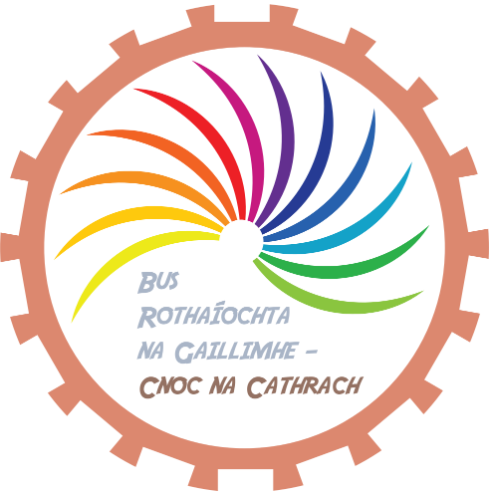
Participation Form
I,____________________, would like my child to participate in the Cycle Bus program .
(print name)

The Cycle Bus will commence at 8.15 every day (weather permitting) and arrive at approximately 8.33 at ………. The Cycle Bus will be marshalled by vetted volunteers from the community, in addition to parents who may wish to join in.
I understand that the Cycle Bus will use public roads, cycle paths and footpaths to guarantee the safest and most suitable route to school.
I acknowledge that my child’s bike is in good mechanical condition, and that their helmet, if used, is properly fitted. My child has the ability to lock their bike in the bike parking area.
I agree to accompany my child by bike if they are in Junior/ Senior Infants or 1st/2nd class along the entire route.
Childs Name:______________________ School: ______________________
(print name)

Parent/Guardian Phone Number:_______________________

Signed: ___________________________ Date: _______________________

D. Letter to parents

Re: School Cycle Bus
We are delighted to let you know that a new Cycle Bus initiative is about to be launched for the students of ……. National School. The School Cycle Bus will be running (cycling!) between ……….... It is starting on the morning of Monday 24th September.
It is a scheme that involves adult volunteers accompanying children to school along a set route, in this case along the ……..., following a set timetable at agreed pick-up points.
This is a brilliant opportunity for the children to engage in a healthy, sustainable way to get to school. It is a great way for the children be active, gain road safety skills and independence. It will be the first of its kind in Ireland. We hope that it will inspire others to follow suit.
The materials for the bus; participation form, route map, timetable, and rules can all be found attached.
Key to the success of the initiative is the participation of adult volunteers who will accompany the children along the route. These could be parents, grandparents, childminders, or older siblings. Children in second class and below will need to be accompanied by their parent/guardian.
If you would be interested in volunteering or have any questions or concerns, please contact ……………..@gmail.com

Go raibh mile maith agaibh as ucht bhur dtacaíocht!

E. Incident sheets
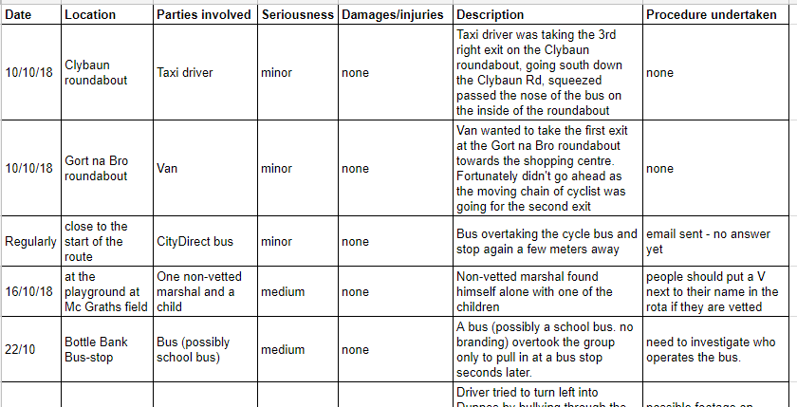

F. Accident report form
Accident Report Form
Please record all details

Date of Accident:
Time:
Place:

Name(s) of injured person(s):
Nature of accident:

Witnesses:

Nature of Injury:

Signature:

G. Marshal rota
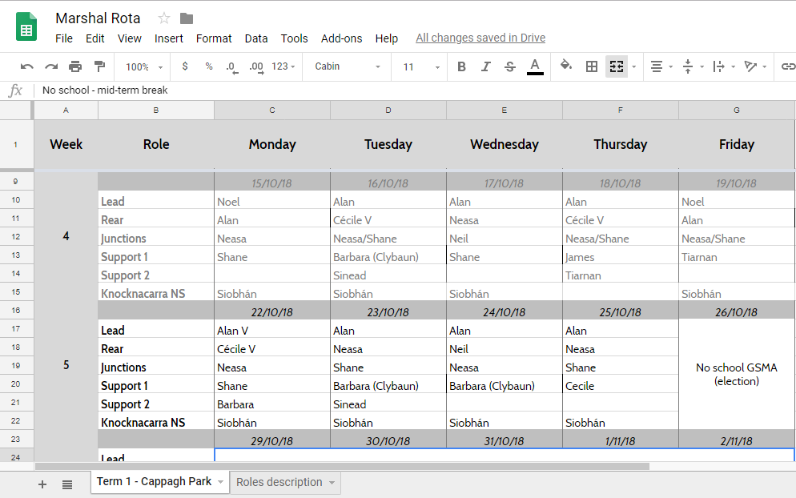

H. Bike maintenance form for parents
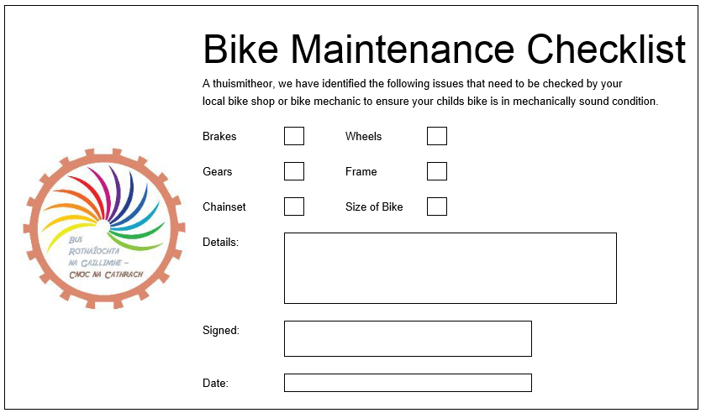

I. The nature of the Cycle Bus route and the current marshalling process.
The Western Distributor Road and the suburb of Knocknacarra.
The Western Distributor Road (WDR) acts as a central spine for the Galway suburb of Knocknacarra. It runs on an east - west alignment roughly parallel to the coast. The corridor itself has almost exclusively a "link" function with very few developments fronting directly onto it. The road itself is 9.2m wide which theoretically gave 4.6m lanes traveling in each direction. Provided traffic speeds and volumes were controlled, for reasonably confident adult or teenage cyclists, this could be considered "friendly" or "forgiving" as 4.6m theoretically allows motor traffic to pass cyclists with adequate clearance while also giving room for cyclists to filter past traffic queues. However, as constructed, the WDR also included six roundabouts, using typical Irish geometry laid out as a series of slip lanes. This roundabout design encourages driver speeds and styles that impose significant risks on two-wheeled traffic such as cyclists and motorcyclists.

A 1987 Irish report on the use of roundabouts in Swords raised serious reservation about using them where two-wheelers might be expected. The presence of these roundabouts made the WDR an inherently unsuitable location for cycling by less assertive cyclists and particularly for children. These roundabouts were also a challenge for people on foot. As constructed, the WDR did not include, and apparently was not intended to include, cycle facilities.

At some point around 2001, narrow cycle lanes were marked on the sections of the road. At that time nothing was done with the roundabouts, so the net effect was that a road that was inherently unsuitable for cycling was being designated as a cycle route by Galway City Council. (Adding cycle lanes between the roundabouts did nothing to address a significant problem with the route).

Knocknacarra itself has been planned with poor permeability away from main roads. For many of the housing estates, the Western Distributor Road could not be avoided when trying to access other locations. Knocknacarra could be fairly described as a place that was designed in an inherently car-dependent manner by Galway City Council from the outset (See below for historical note on the Western Distributor Road).

In 2016, works took place on the roundabouts to install raised zebra crossings and in some cases, the number of lanes entering the roundabouts was reduced. These changes to the roundabouts have made a significant improvement in the road for both walking and cycling. It is likely that the Cycle Bus could not have happened at all without this. However, the provision of the zebra crossings is not complete and there are prominent locations where none have been provided.

Traffic conflict analysis for the purpose of marshalling.
The overall layout of the road has some advantages for marshalling the Cycle Bus. Because there are few fronting developments, there is little demand for roadside car parking - at least at the time the Cycle Bus tends to operate. So dealing with parked cars is an issue. However there may be buses and taxis parked, which are dealt with below. At the time the Cycle Bus operates, there are few turning movements by drivers between the roundabouts. The nature of the corridor also means that the Cycle Bus is not making turns against oncoming traffic.

Junction conflicts
A key traffic conflict to be managed by the marshals, is junction conflicts. There are comparatively few side roads apart from the roundabouts and these tend to be lightly trafficked. This means that so far the junction marshals have been able to concentrate on the roundabouts. At the roundabouts there are two potential traffic conflicts: 1) traffic turning across the Cycle Bus from the right; 2) traffic entering from the left. Because the zebra crossings are raised, this tends to reduce entering speeds from the left. However, at several of the roundabouts, there is no traffic calming to slow vehicles coming from the right. This means intercepting traffic from the right is the key task for the marshals.

The diagrams below illustrate the process at the roundabouts:

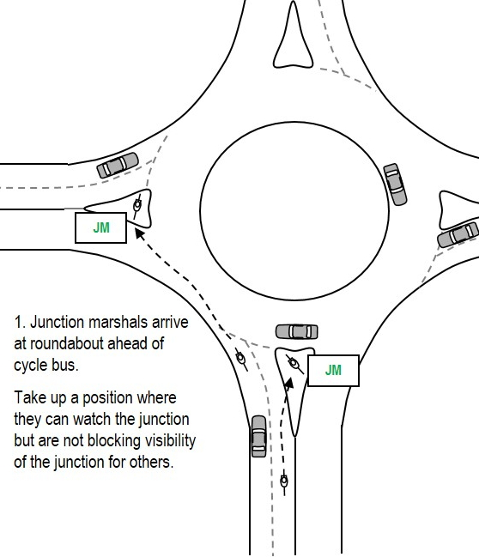 | 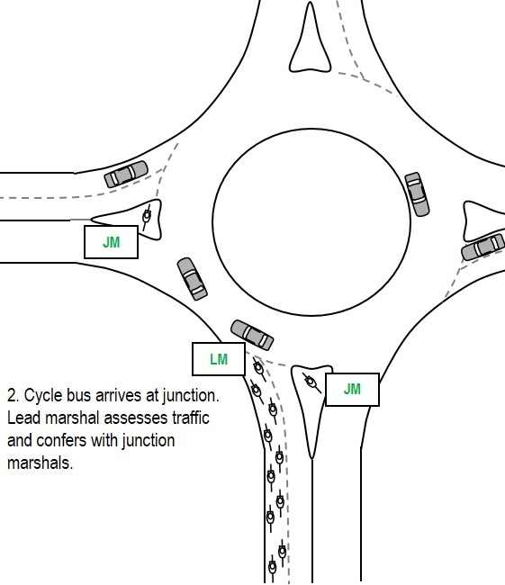
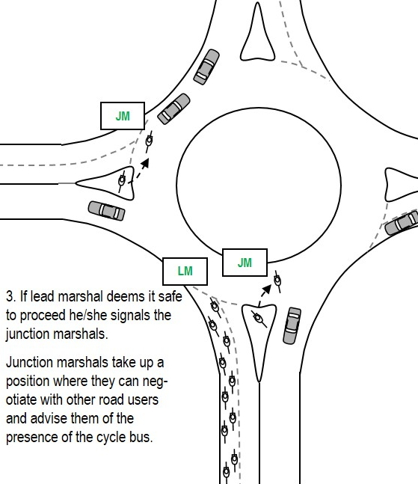 | 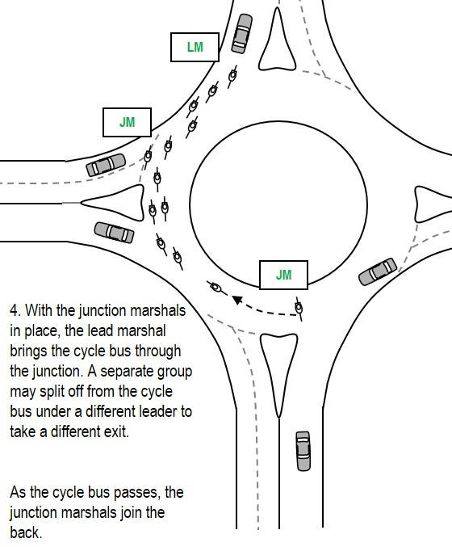

The junction marshals and the lead marshals wait for a gap in traffic. Then if safe to do so, they move out to a position that will allow them to negotiate with other drivers entering the junction. If a driver communicates an unwillingness to allow the Cycle Bus free passage, then the marshals must stop the Cycle Bus and ensure the participants are safe. Once this is done, that driver is allowed to proceed and the negotiation process starts with another driver. It has been found that as the Cycle Bus gets more well known, some drivers will stop to allow the bus to proceed without the marshals actually doing anything. In heavy traffic, the Cycle Bus does not filter through the cars. If a roundabout is blocked with traffic, the marshals walk the Cycle Bus through the junction using the zebra crossings.

Marshaling pinch points and obstructions
At the western end of the WDR, there are central traffic islands that create pinch points. This means that at these places, there is not physically enough room for a motor vehicle to pass safely. The rear marshals watch for these locations and before the Cycle Bus reaches the pinch point, the marshals move to a primary road position, where they are controlling the lane. The purpose of this is to discourage following drivers from starting an overtake that cannot be completed safely. If possible the marshals “look behind”, make eye contact with following drivers, and try to impart that the inconvenience is temporary. Once the pinch point is passed, the marshals move back to the left and give following drivers a thumbs up to show the restriction is over. If there is no oncoming traffic, the following traffic overtakes and the marshals will wave their thanks to the drivers for their patience.

If there is an obstruction such as a parked bus, a similar process applies. The rear marshals move out to a control position before the Cycle Bus gets to the obstacle, so that there is a gap that the children and parents can move into. If the bus is simply taking on passengers then the Cycle Bus might simply stop behind and wait for the driver to finish loading and move off.

Filtering
On the section of the WDR without cycle lanes, the Cycle Bus does not filter past traffic in same lane, but stops and waits. On other section,s the Cycle Bus does use the cycle lanes to maintain progress past traffic queues. That said, it is important to note that there are few side entrances and few turning movements by other traffic across the bus between the roundabouts. If there were busy side roads, it would be necessary to find a means to marshal these before the Cycle Bus could pass them on a cycle lane. It cannot be assumed that drivers of turning motor vehicles will treat a cycle lane as a separate lane or yield to crossing cyclists. At the roundabouts, the Cycle Bus has a policy of stopping to assess before proceeding, so this reduces the opportunity for conflict with turning drivers.

Left-turning drivers
One conflict that has occurred with turning drivers involves drivers coming up from behind the Cycle Bus, with the intention of turning left across the Cycle Bus at the roundabouts. Following drivers may try to left-hook the front of the Cycle Bus to get through the roundabout first. Alternatively, one driver has attempted to come from behind and push left through the middle of the Cycle Bus as it was passing through a roundabout. At this time, the marshaling team does not specifically position someone to guard against this. The lead marshal can use positioning somewhat to discourage a left-hook, but this only works with the front of the Cycle Bus. Like other situations, the rear marshals can use positioning to deter following traffic coming up beside the bus at the junction, but if there are multiple lanes this might appear unreasonable - also not all drivers will actually want to turn-left and so are not a source of conflict. At this time, the marshaling strategy is to be aware of the possibility and watch for it and be ready to warn others if it appears something like that is about to happen. As the marshalling team gains experience, a more formal pre-emptive tactic might develop, but may be dependent on the number of marshals available.

The best protection for the individual Cycle Bus participants is for them all to understand that they are allowed to stop if another road user encroaches on them. They also need to understand that they may need to stop immediately, if they hear a warning from the marshals or other participants. This underlines the need for the marshals to avoid “rushing” the bus or generating a sense of hurry, while at the same time keeping the Cycle Bus moving as a single block without gaps. This might reduce the temptation for opportunistic manoeuvres by turning drivers. It reinforces the need to move at a sustainable speed for all participants and to regroup from time to time.

Starting stopping and picking up participants at the stops
When the Cycle Bus is starting from being stopped, the marshals treat the situation like the obstacle process and use positioning to create a protected gap. Smaller children will wobble or swing out when trying to get started, so this should be expected. In addition, some children are carrying heavy loads relative to their size - this will also affect their ability to control at very slow speeds. Some children may be offered instruction on starting and stopping, but they cannot be assumed to have mastered these techniques.

If the Cycle Bus must stop, the marshals must also be aware that the participants may need extra space in that moment. This also applies if the Cycle Bus is then dismounting to walk. As the Cycle Bus stops at each pick up point, the participants join at the back in front of the rear marshals. Again, it must be expected that some of the children may swing out into the road while joining. The rear marshals need to allow for this in advance and use their own road position to protect a space for them. The new raised zebra crossings at the roundabouts provide a good location for the children to join and also for the rear marshals to protect.

Historical note: The construction of the inherently hostile Western Distributor road was fought at the time by the Galway Cycling Campaign, with planning objections and complaints to the EU commission regarding the inappropriate use of EU funds. In one case a planning objection was logged against one of the roundabouts - the planning application for the roundabout was withdrawn - but the roundabout was constructed anyway. In 2001 when the cycle lanes first appeared they were only 1.2m wide, this was considered dangerously narrow and contrary to best practice. The Cycling Campaign appealed to the Garda Commissioner to intervene and use powers available under the road traffic act and have the lanes removed.

